- Design DFA using simulator to accept the input string “a” ,”ac”,and ”bac”.
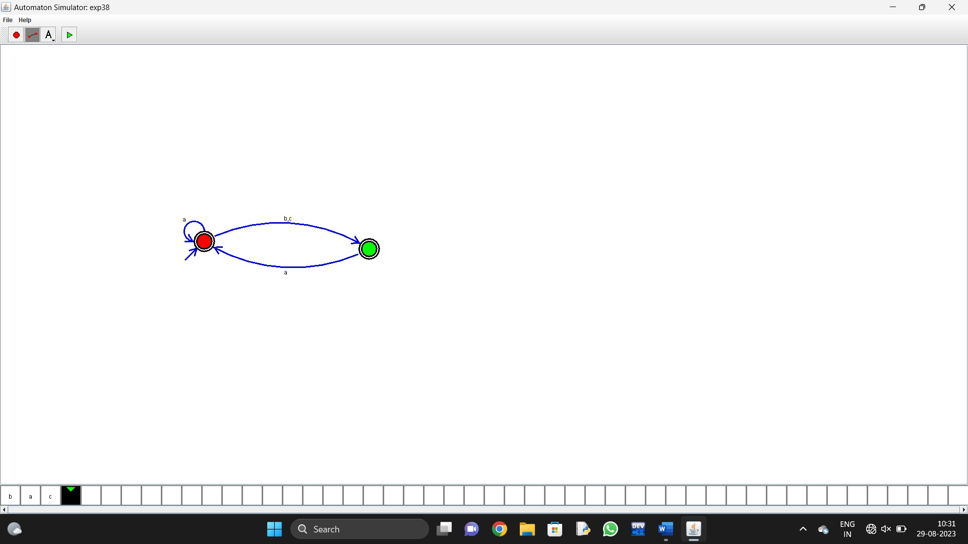
13.Design PDA using simulator to accept the input string a

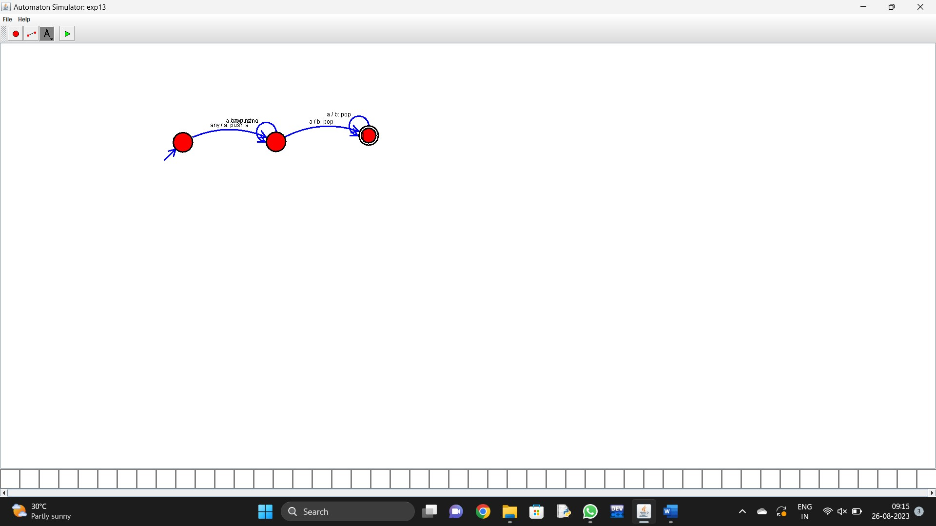
- Design PDA using simulator to accept the input string a^{n}b^{2n}

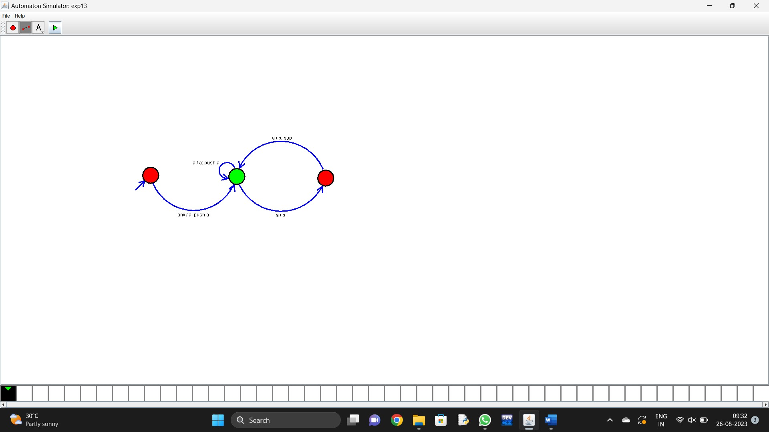
- Design TM using simulator to accept the input string a^{n}b^{n}

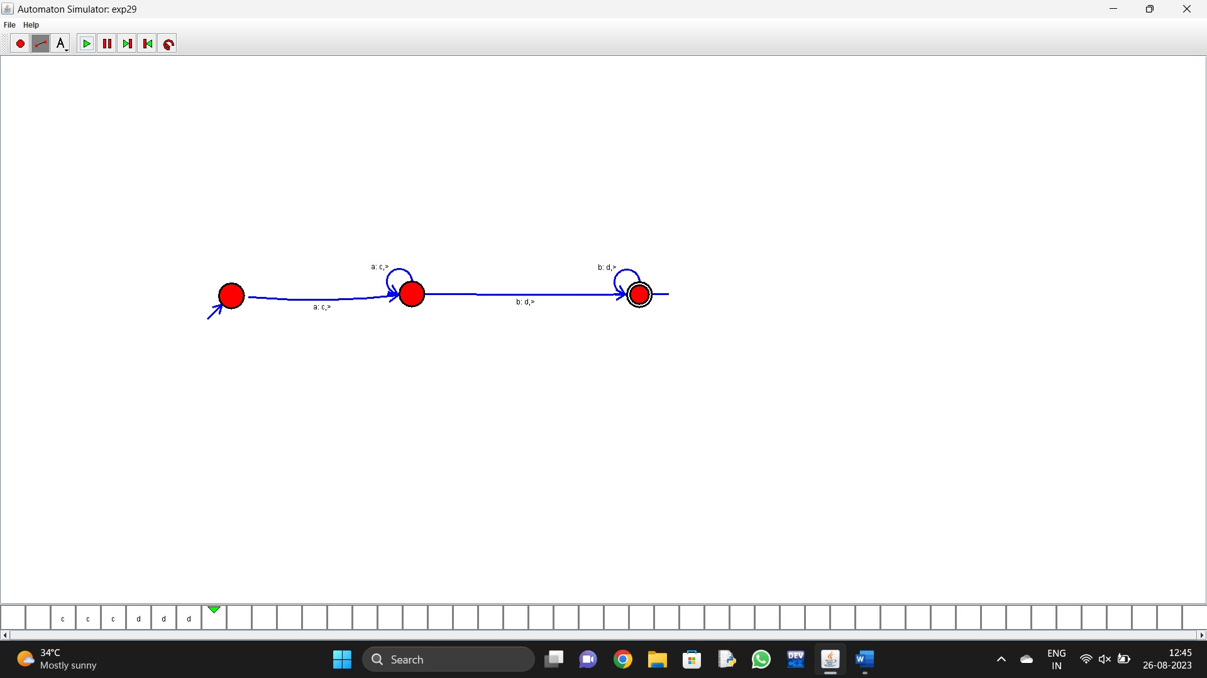
- Design TM using simulator to accept the input string a^{n}b^{2n}
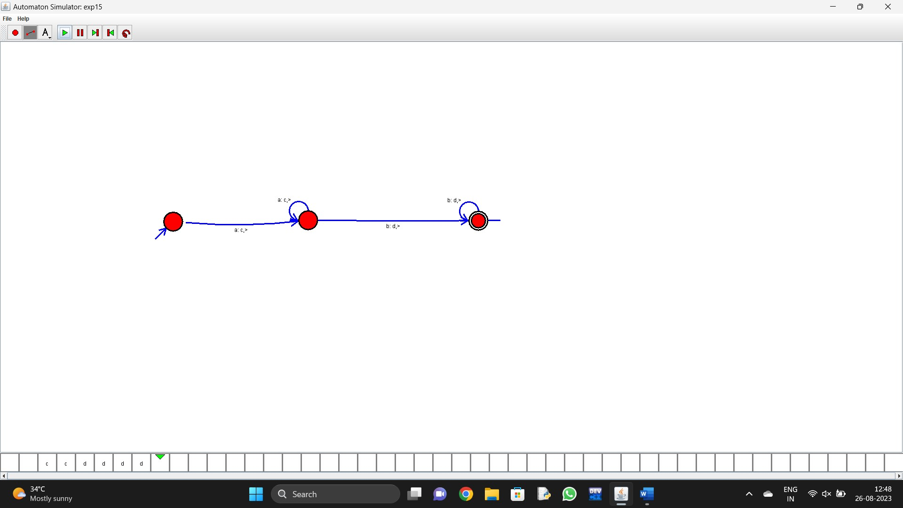
- Design TM using simulator to accept the input string Palindrome ababa
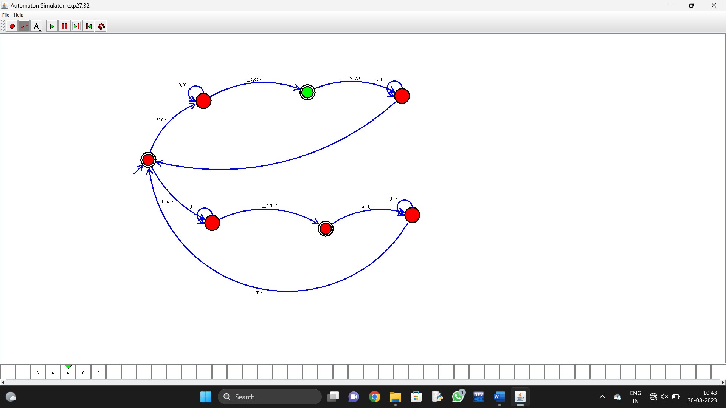
- Design TM using simulator to accept the input string ww

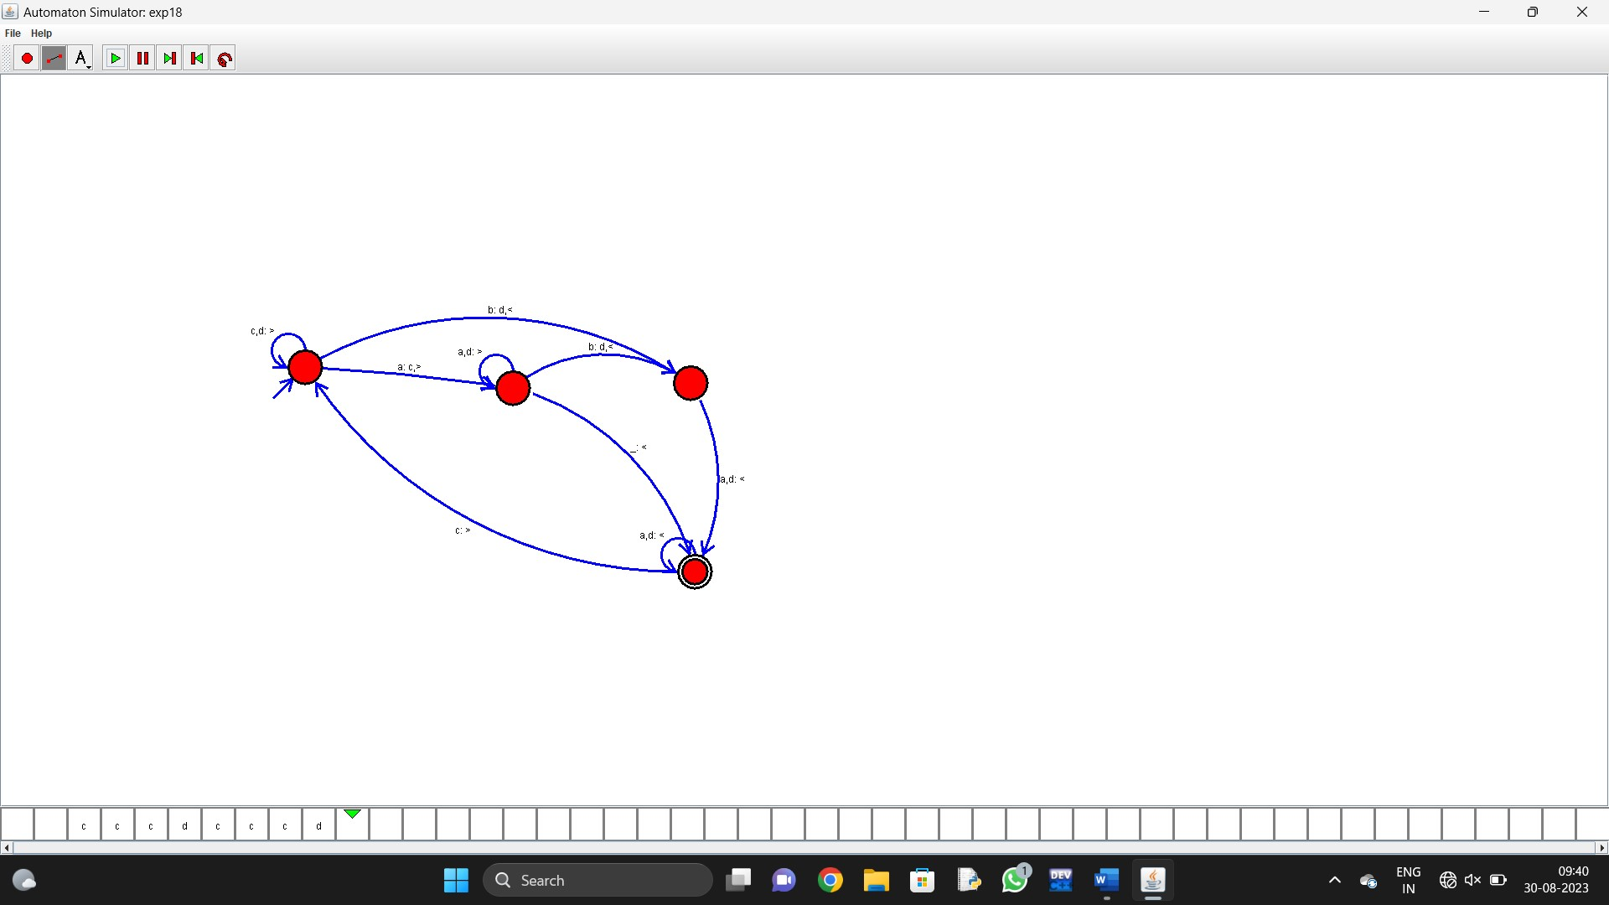
- Design TM using simulator to perform addition of ‘aa’ and ‘aaa’
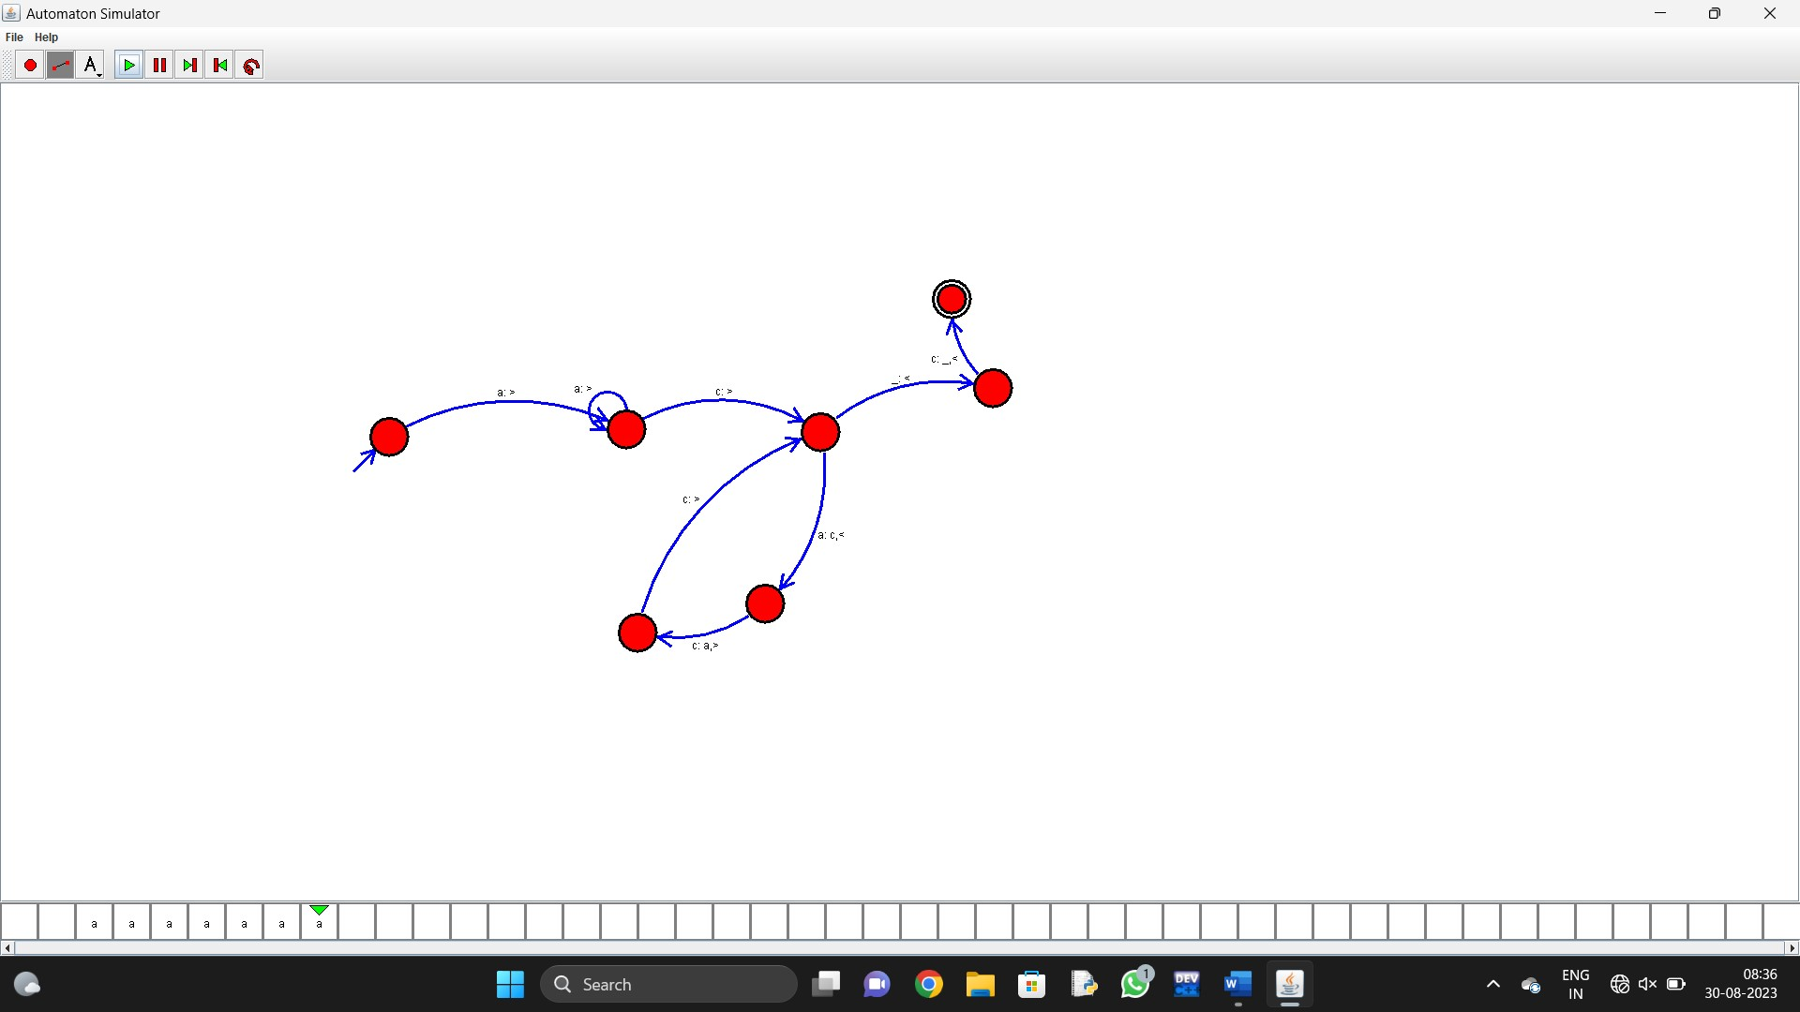

- Design TM using simulator to perform subtraction of aaa-aa
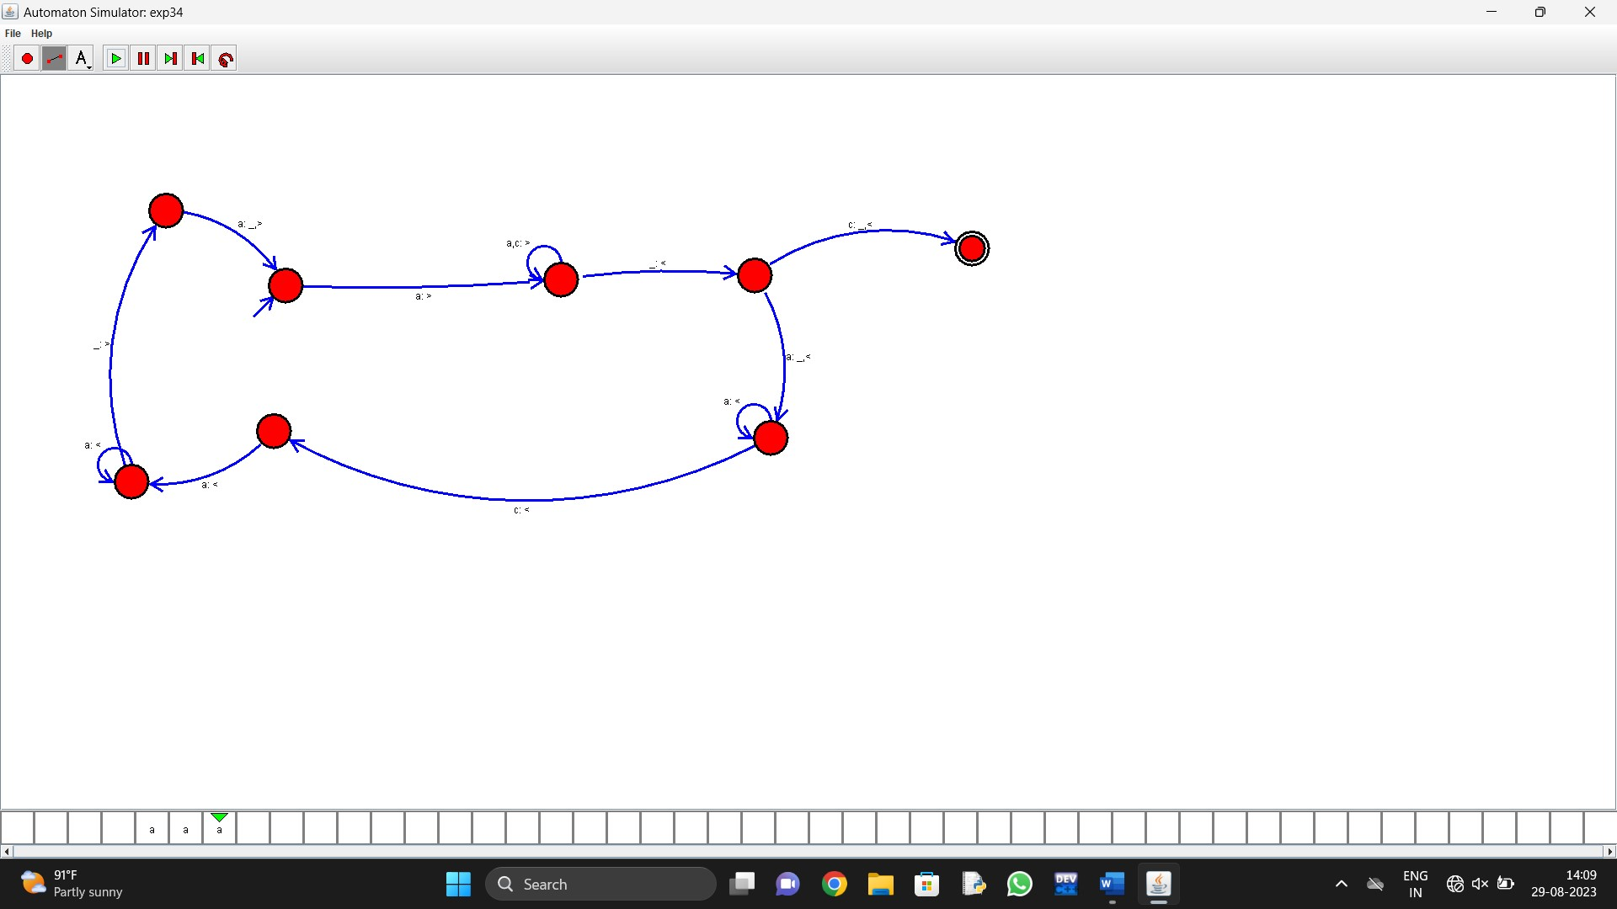

21. Design DFA using simulator to accept even number of a’s.

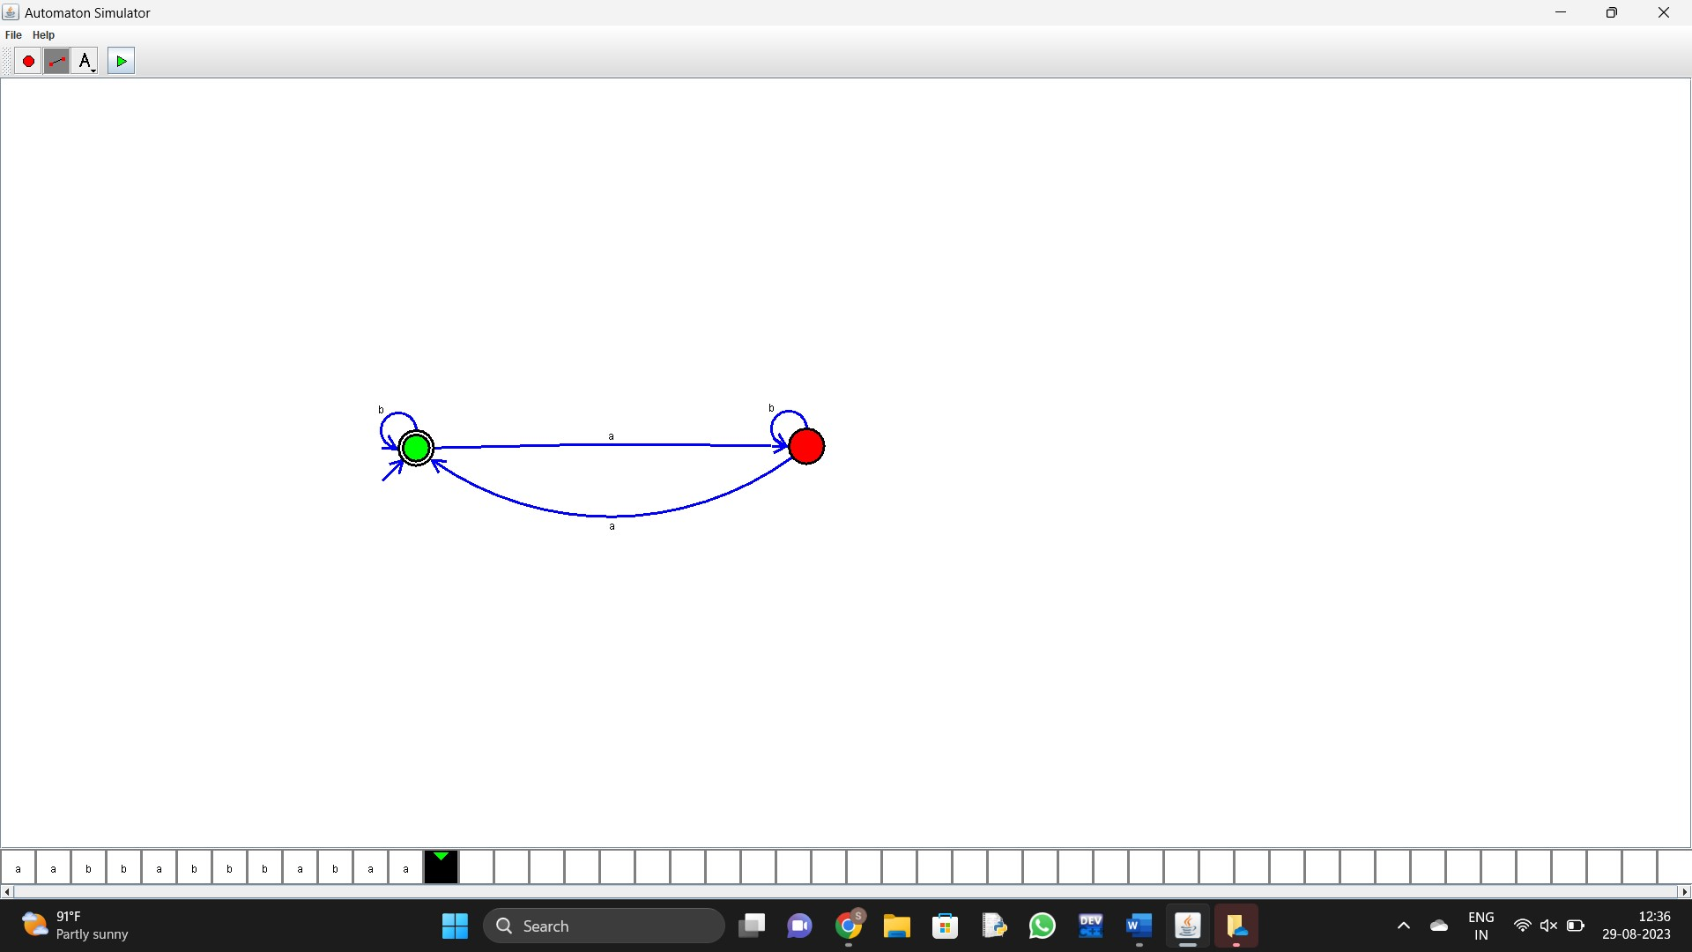
- Design DFA using simulator to accept odd number of a’s

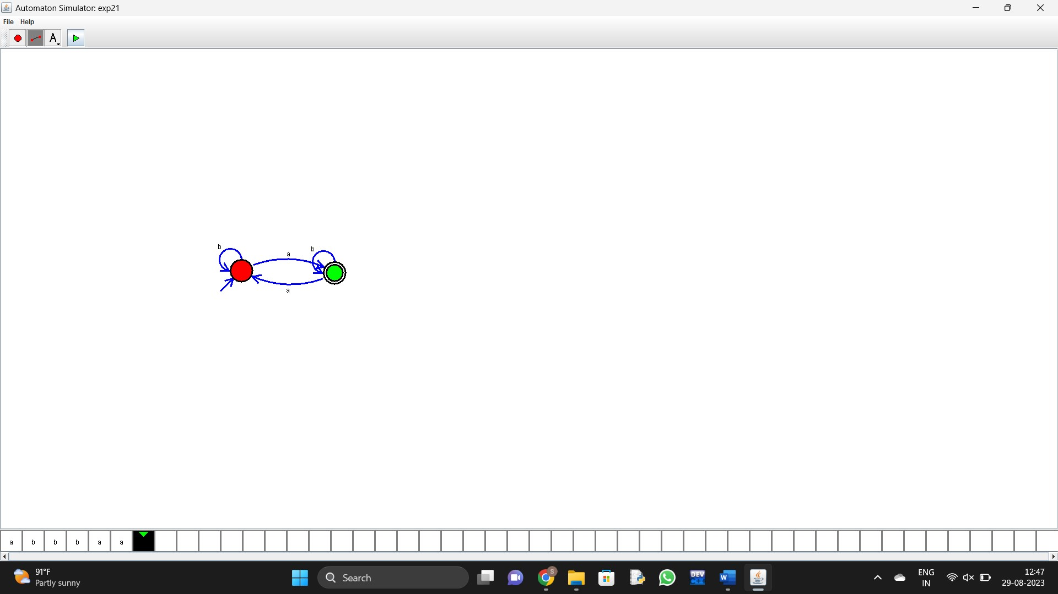

- Design DFA using simulator to accept the string having ‘ab’ as substring over the set {a,b}

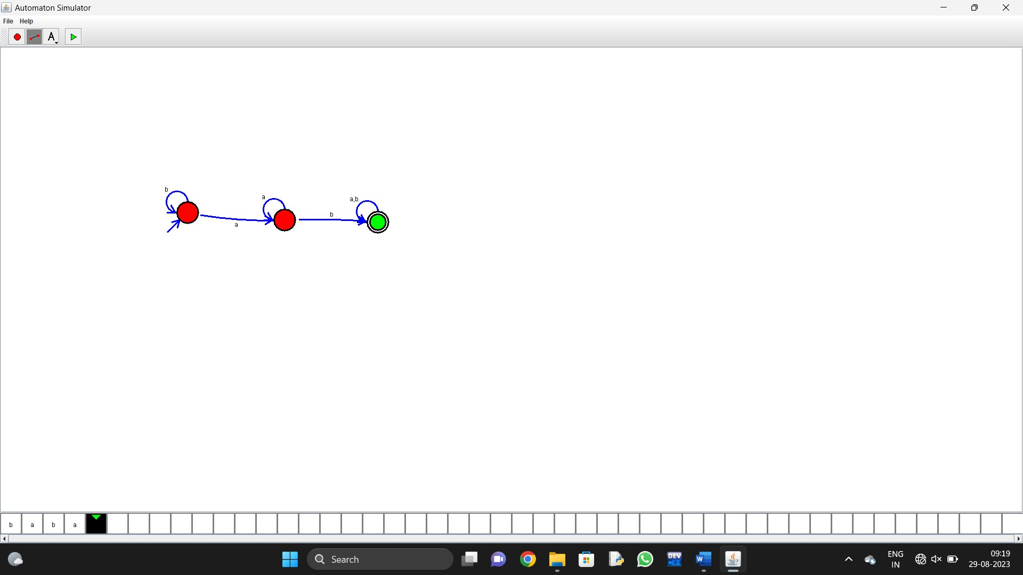
24. Design DFA using simulator to accept the string having ‘ab’ as substring over the set {a,b}

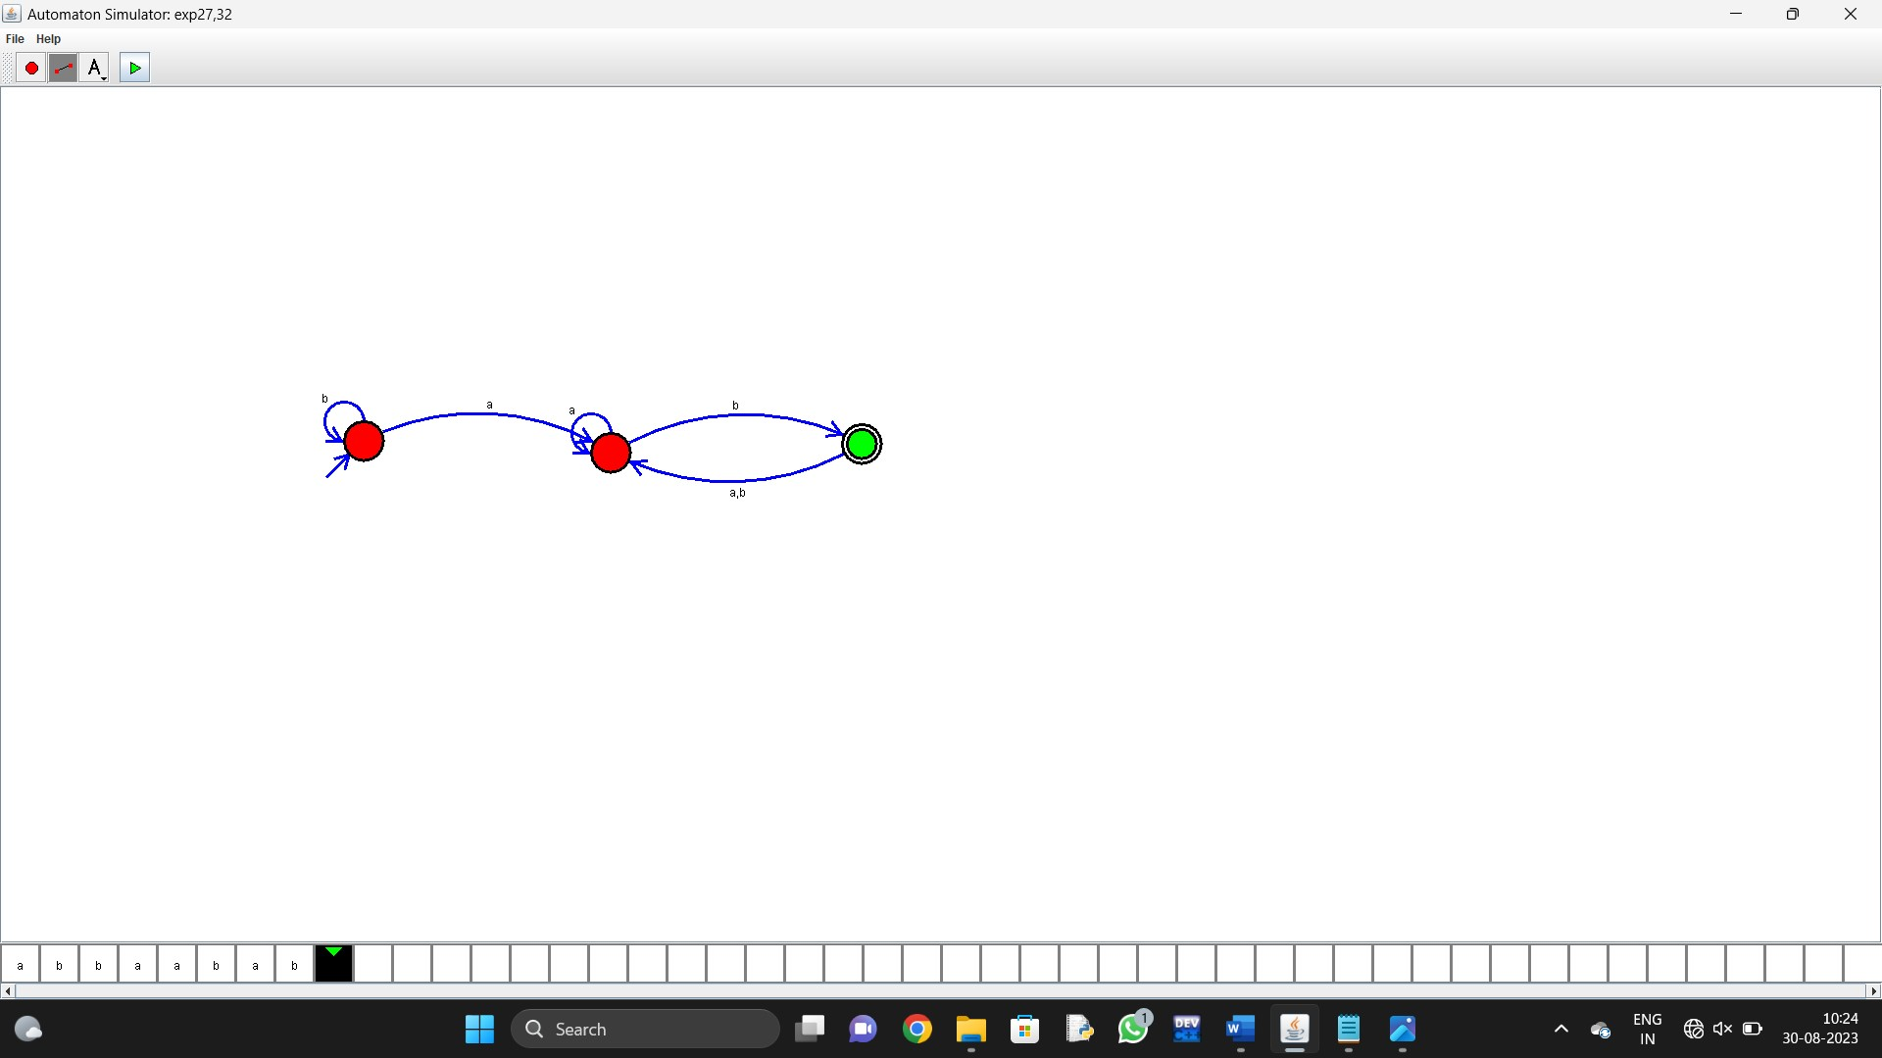
- Design DFA using simulator to accept the string start with a or b over the set {a,b}

- Design TM using simulator to accept the input string Palindrome bbabb

27. Design TM using simulator to accept the input string wcw
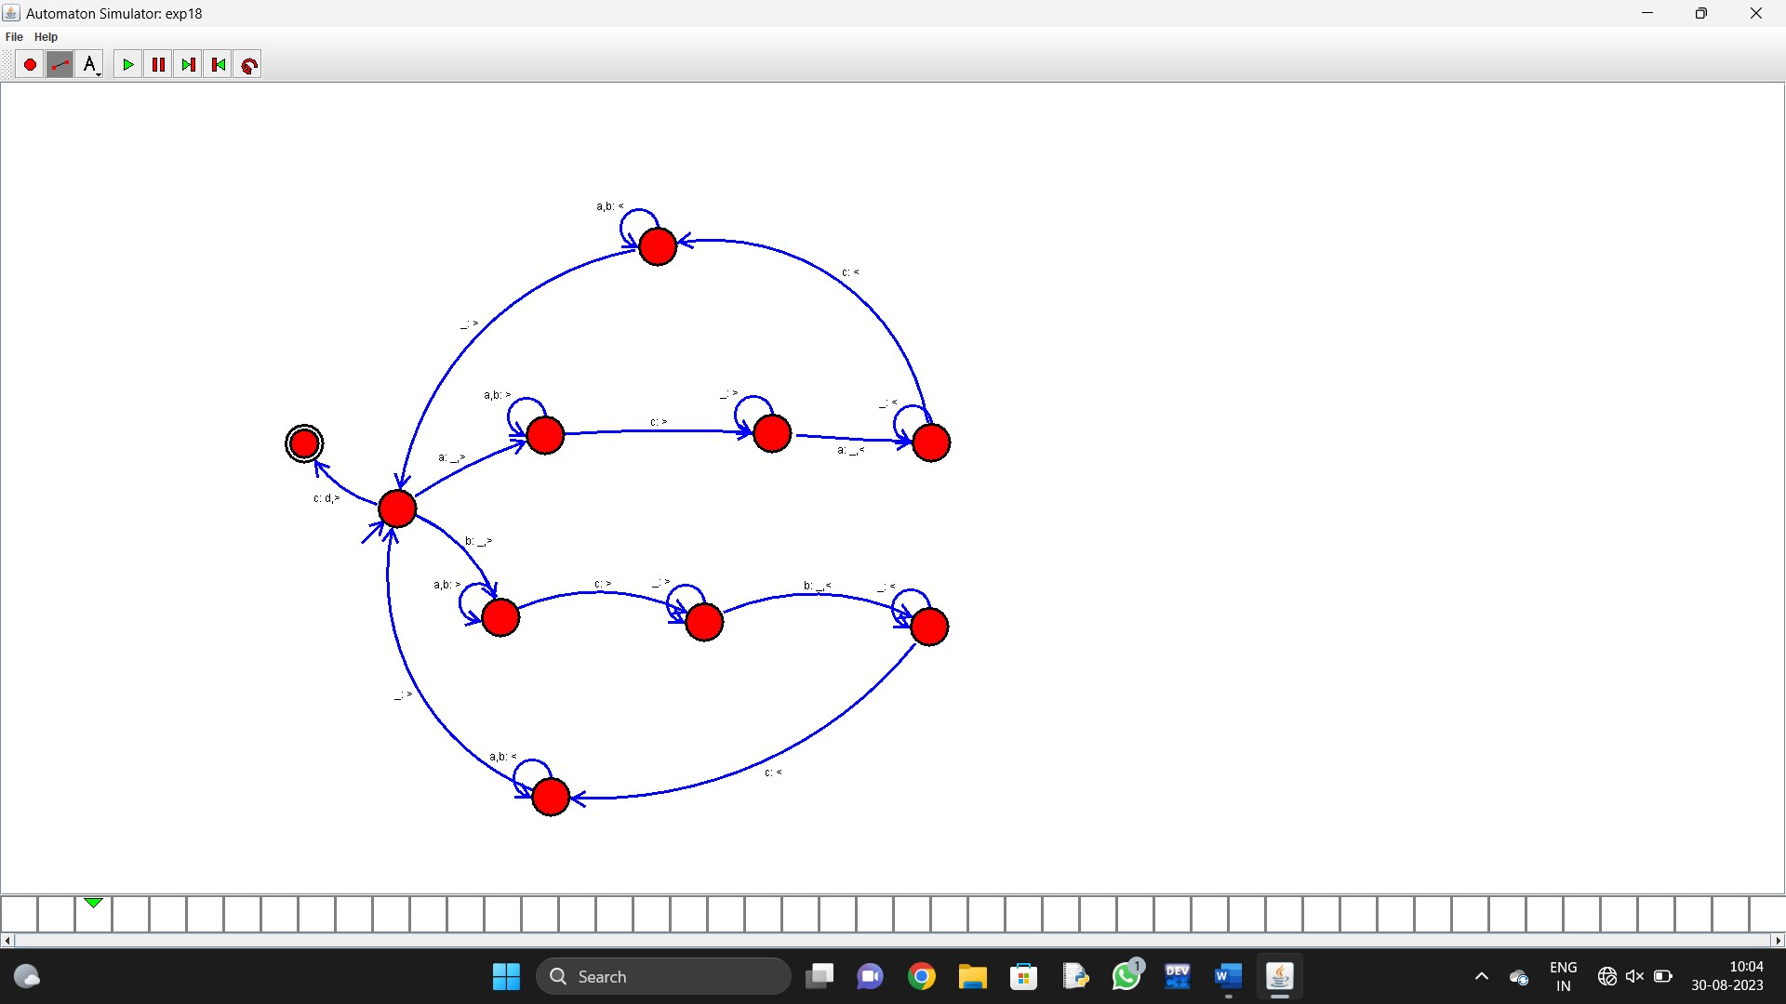

- Design DFA using simulator to accept the string the end with ab over set {a,b)
W= abbaabab

- Design DFA using simulator to accept the input string “bc” ,”c”,and ”bcaaa”.

- Design NFA to accept any number of a’s where input={a,b}.

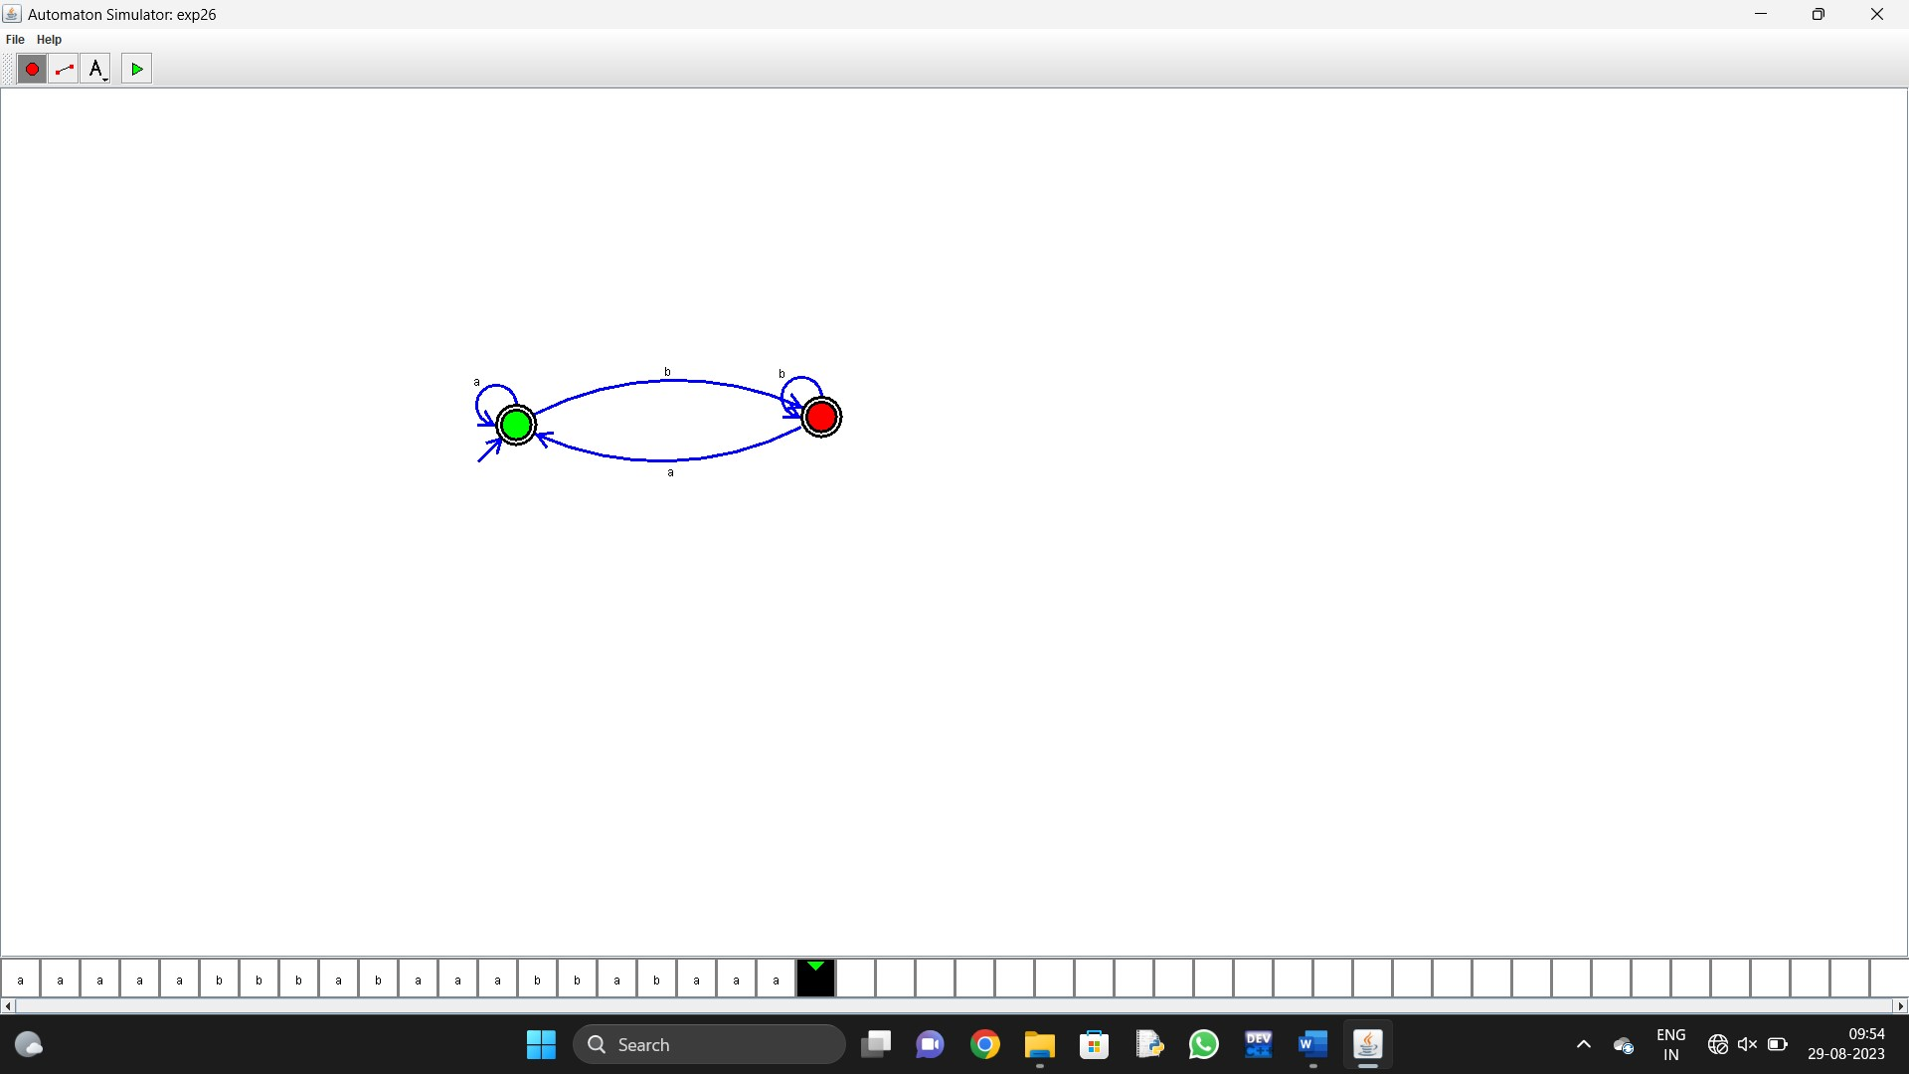
- Design PDA using simulator to accept the input string a^{n}b^{n}

- Design TM using simulator to perform string comparison where w={aba aba}
- Design DFA using simulator to accept the string having ‘abc’ as substring over the set {a,b,c}

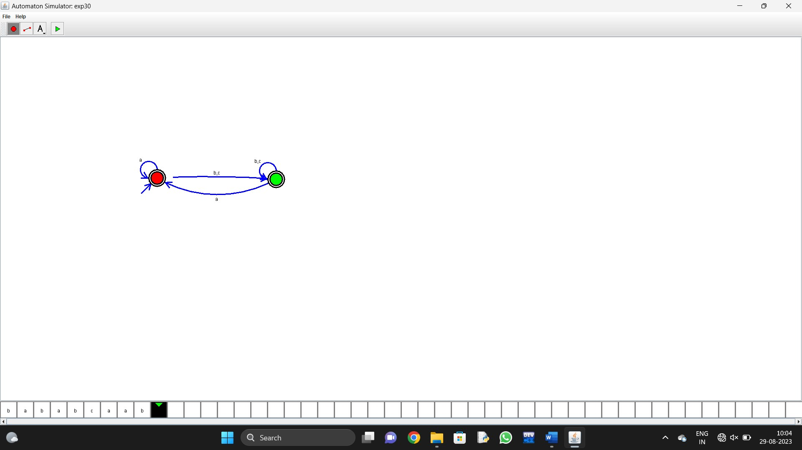
- Design DFA using simulator to accept even number of c’s over the set {a,b,c}

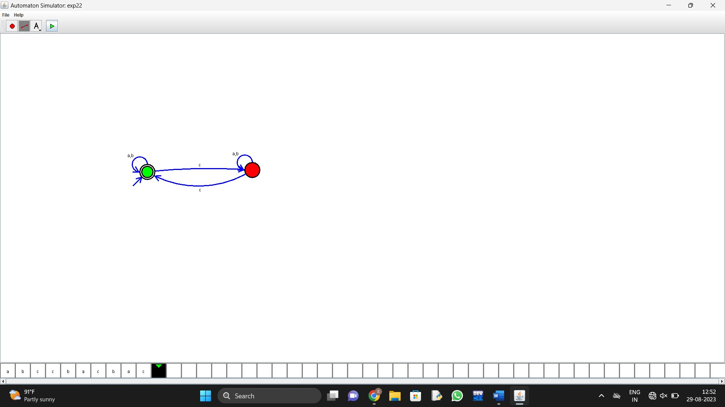

- Design DFA using simulator to accept strings in which a’s always appear tripled over input {a,b}

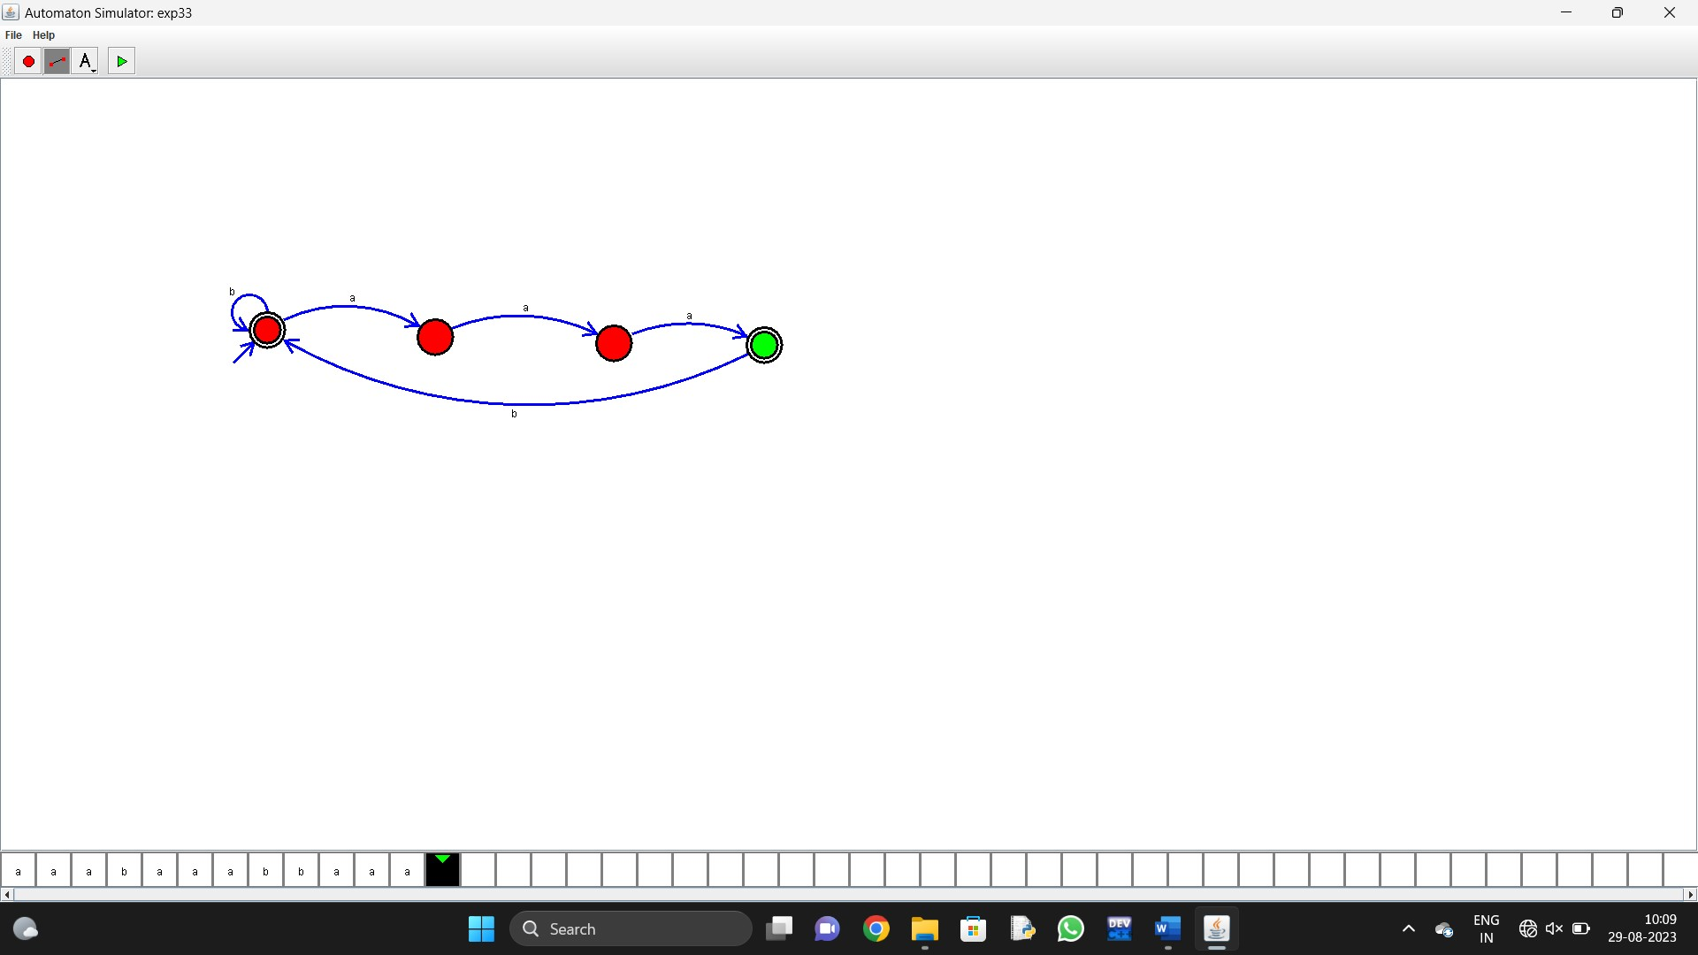

- Design NFA using simulator to accept the string the start with a and end with b over set {a,b} and check W= abaab is accepted or not.
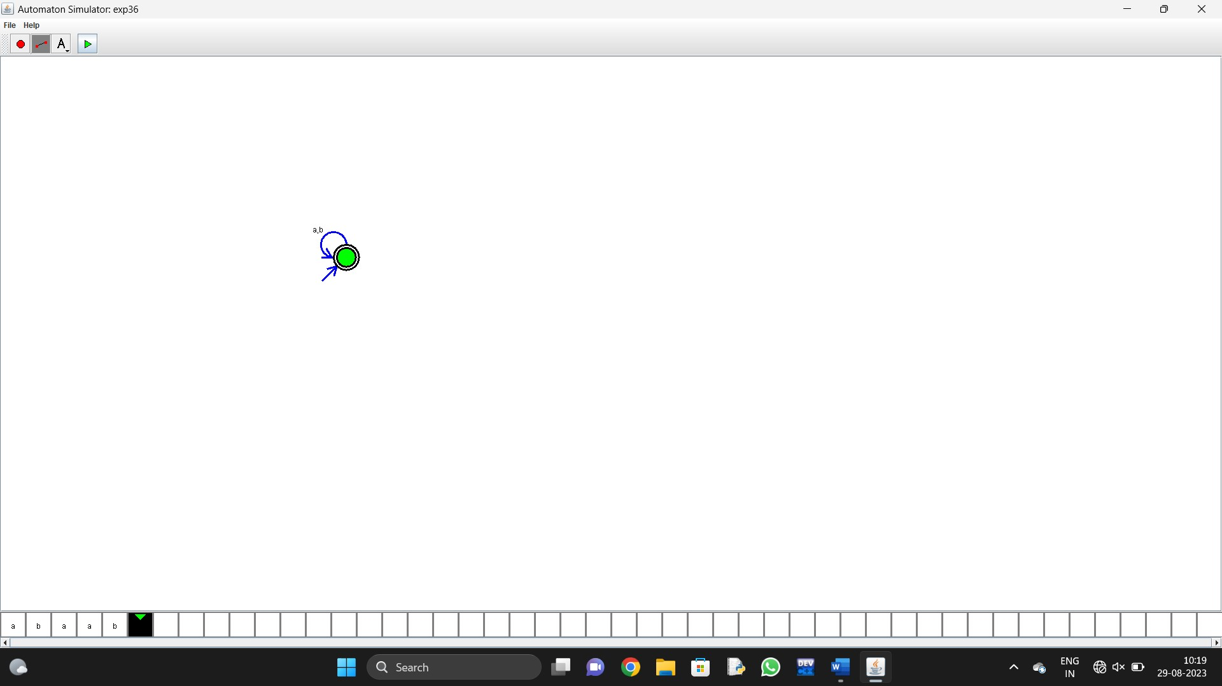
- Design NFA using simulator to accept the string that start and end with different symbols over the input {a,b}.
- Design NFA using simulator to accept the input string “bbc” ,”c”,and ”bcaaa”.

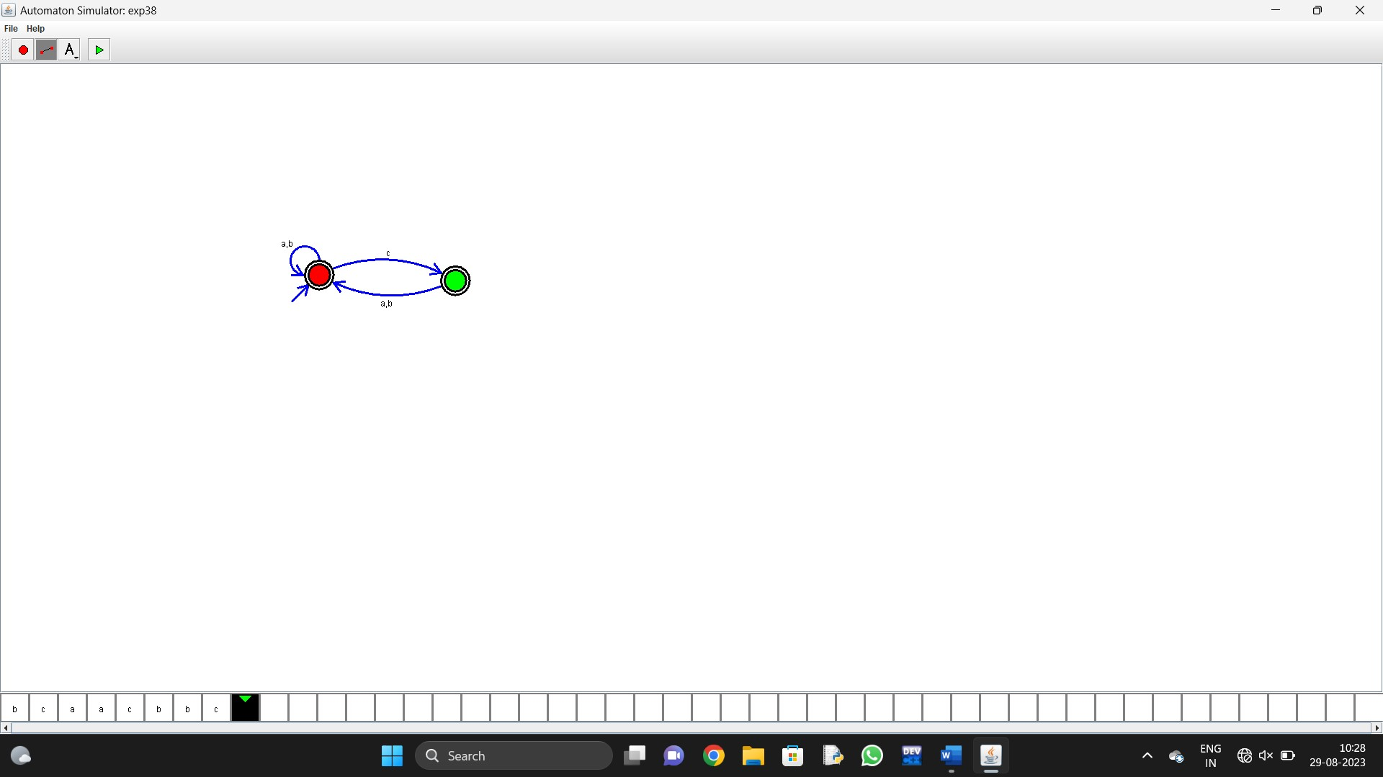
- Design DFA using simulator to accept the string the end with abc over set {a,b,c)
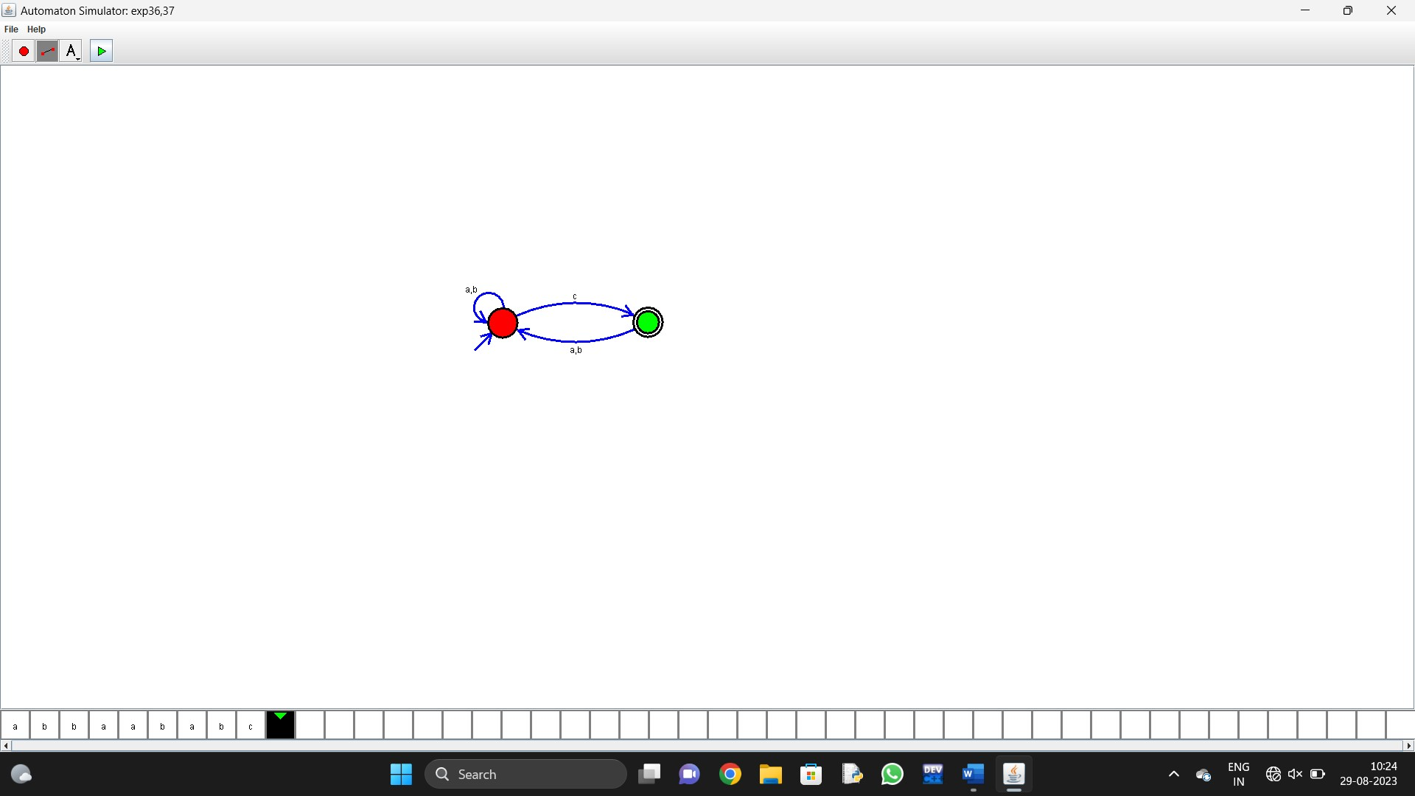
- Design NFA to accept any number of b’s where input={a,b}.

